

**Department of Information and Communication Technology**

**Faculty of Technology**

**University of Ruhuna**

System Requirements Specification

Database Management Systems Practicum

ICT 1222

Group 08

Group Members:

TG/2021/1057 - W.A.K.P. Lakshan

TG/2021/1064 – K.A.N. Perera

TG/2021/1052 – G.A.I. Rangajeewa

TG/2021/1035 – A.M.S.S. Kumara

Table of Contents

Introduction 3

Purpose 3

Scope of Management System of TECLMS-TECMIS. 3

System Overview 4

Overview of the TECLMS-TECMIS system 4

Context Diagram 4

Features/Modules of the system to be implemented 5

Function Requirements 5

Function Requirements of Admin 5

Function Requirement of Dean 5

Function Requirement of lectures 6

Function Requirement of Technical Officer 7

Function Requirement of Students 7

Non-Functional Requirements 7

Performance 7

Reliability 8

Security 8

Usability 8

# Introduction

## Purpose

The purpose of creating a Software Requirement Specification document for a Database Management system in the context of a Student Management System is to clearly define the function and nonfunctional requirements of the system. After this, the project will be called TECLMS-TECMIS.

## Scope of Management System of TECLMS-TECMIS.

The TECLMS-TECMIS system helps to manage the registration and enrollment of students, course details, student marks, attendance medical submission. The system is in the admin, student, lecturers, and technical officer. Each of the users has specific authorities in the system. Those are,

* Maintenance of student records, including student details
* Course management
* Academic record management
* Document management
* Data management
* Manage faculty and staff.
* Financial management and budgeting

It’s important to note that the scope of a TECLMS-TECMIS can vary greatly depending on the educational institution’s size, specific needs, and technological infrastructure.

# System Overview

This system overview serves as a foundation selection of the project documentation, offering stakeholders a concise understanding of TECLMS-TECMIS’s purpose, components, key functionalities, and security considerations. It provides a high-level perspective before delving into more detailed sections of the project documentation.

It helps in managing the academic and administrative data of students. TECLMS-TECMIS converted to a web-based application, it provides various features for each user profile, such as students, lecturers, dean, and technical officers.

## Overview of the TECLMS-TECMIS system

TECLMS-TECMIS database management system is a comprehensive software solution designed to efficiently manage student-related data at Ruhuna University. The project aims to streamline and automate various administrative and academic processes, enhancing the university’s ability to provide high-quality education and services to its students.

## Context Diagram

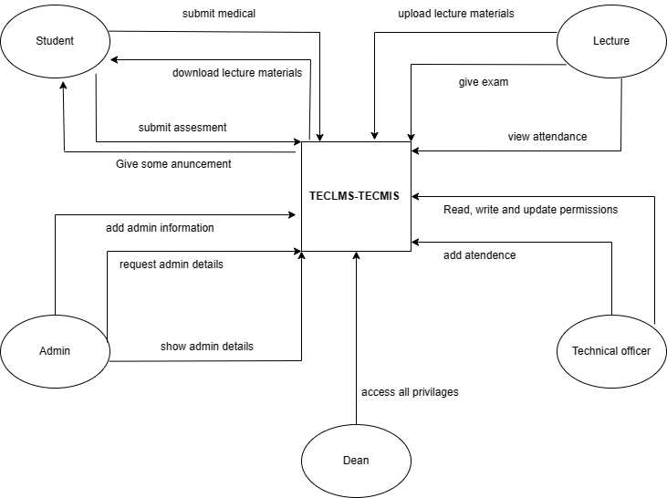

## Features/Modules of the system to be implemented.

There are five (5) common features of the TECLMS-TECMIS Student Management system Database design such as.

1. Admin
2. Dean
3. Lecture
4. Technical Officer
5. Student

# Function Requirements

## Function Requirements of Admin

Function requirements for the Admin in aTECLMS-TECMIS database management system typically revolve around system management, user management, and ensuring the smooth operation of the system.

* Create, update, and delete user accounts for administrators, teachers, and staff members.
* Reset passwords and manage account access.
* Add, edit, or delete student records.
* Update course information, including course schedules and prerequisites.
* Manage academic records, including grades, transcripts, and attendance.

## Function Requirement of Dean

Dean in a TECLMS-TECMIS database management system typically plays a key administrative role in overseeing academic programs, student records, and faculty. Their functional requirements are focused on academic management, ensuring compliance with educational standards, and facilitating effective decision-making.

* Review and approve new academic programs, courses, or curriculum changes.
* Monitor and assess the quality and effectiveness of the existing academic program.
* Manage faculty and staff assignments and workload.
* Develop, update, and enforce academic policies and standards.

## Function Requirement of lectures

Lectures play a crucial role in a TECLMS-TECMIS database management system primarily related to their interactions with students, course management, and academic activities.

* Access and manage course information, including course syllabi, schedules, and materials.
* Assing and updating course content, such as lectures, assignments, and readings.
* View class rosters and student enrollment.
* Mange student adds, drops, and waitlists.
* Generate attendance reports.

## Function Requirement of Technical Officer

A Technical officer in a TECLMS-TECMIS database management system often plays a pivotal role in ensuring the smooth operation, maintenance, and technical support of the system.

* Administer and maintain the TECLMS-TECMIS database management system.
* Ensure system availability and reliability.
* Provide technical support and assistance to system users, including administrators, faculty, and staff.
* Troubleshoot and resolve user-reported issues.
* Plan, schedule, and apply software updates, patches, and bug fixes.

## Function Requirement of Students

Students in a TECLMS-TECMIS database management system often have limited administrative functions but require access to specific features and information related to their academic journey.

* Log in securely to the system using their credentials.
* Browse and search for available courses.
* Access and view class schedules, including dates, times, and locations.
* Check their own attendance records for each course.

# Non-Functional Requirements

Thereare a lot of software requirements included in the non-function requirements of the TECLMS-TECMIS database management system which contains various processes, namely security, performance, maintainability, and reliability.

## Performance

* The system should provide quick response to user queries and action.
* The system should be scalable to accommodate a growing number of users, courses, and data without significant performance degradation.
* The system should support a minimum of 100 transactions.

## Reliability

* Ensure that data remains consistent and accurate even during system failures or crashes.
* Regularly back up data and establish disaster recovery procedures to ensure data can be restored in case of system failures.

## Security

* Protect student data from unauthorized access or breaches through encryption and access controls.
* Implement role-based access control (RBAC) to restrict access to sensitive data based on user roles.
* Maintain comprehensive audit logs to track user activities and data modifications for security and compliance purposes.

## Usability

* Ensure that the user interface is intuitive, user-friendly, and accessible to users with disabilities.
* Provide user training resources to ensure users are proficient in using the system.
* Ensure the system complies with accessibility standards (e.g., WCAG) to accommodate users with disabilities.